Samarth Rural Educational Institute’s
Samarth College of Computer Science, Belhe
Academic Year 2026-2027(SEM-V)
T.Y.B.Sc.(Information Technology)
Practical NO:8
Title : 8. Database Connectivity
Roll NO: 70 Batch : C

SET A :
Q1. Create a Flask application and connect it with PostgreSQL. Display "Database Connected Successfully" in the browser.
Q2. Create a Flask application connected with PostgreSQL. Connect database and create Student table.
Q3. Create a Flask application connected with PostgreSQL. Insert 5 student records into the Student table.
Ans:
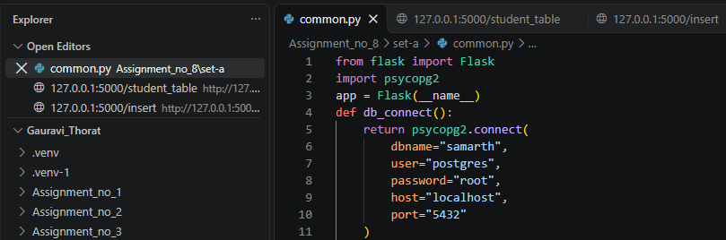
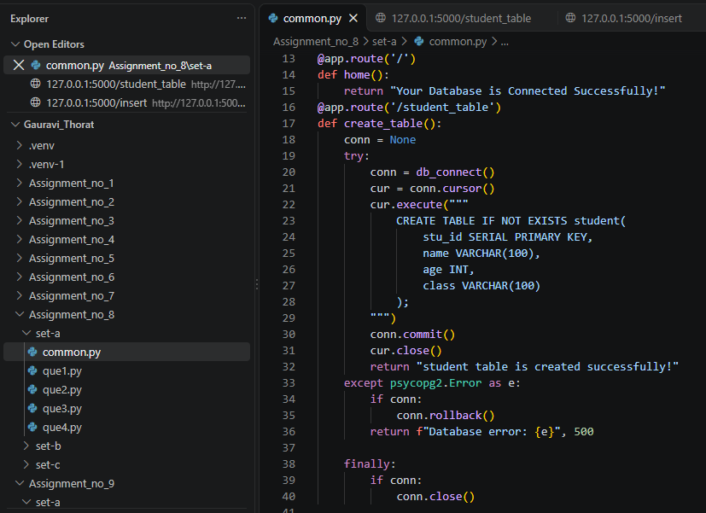
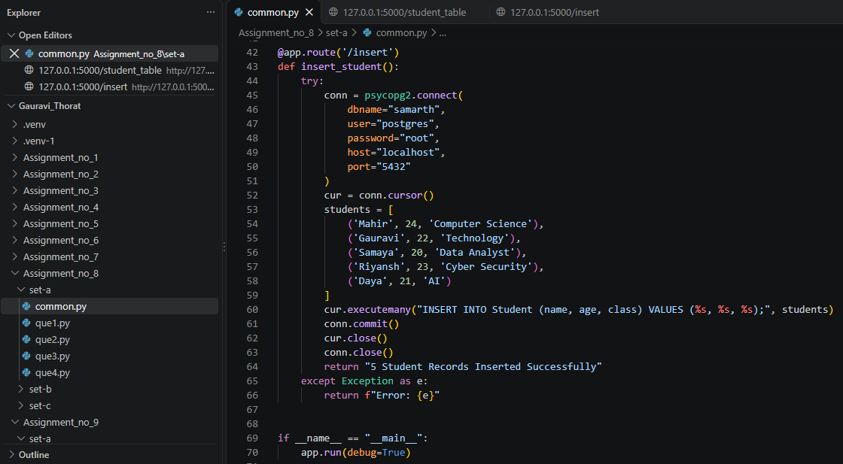
Output:
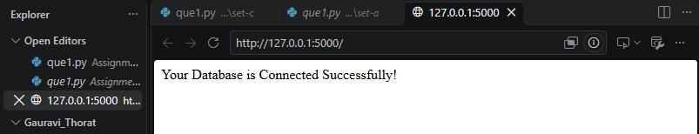
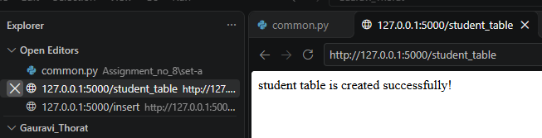
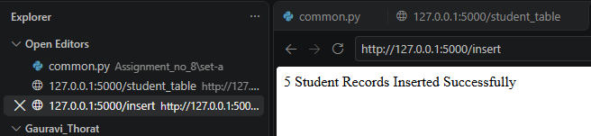
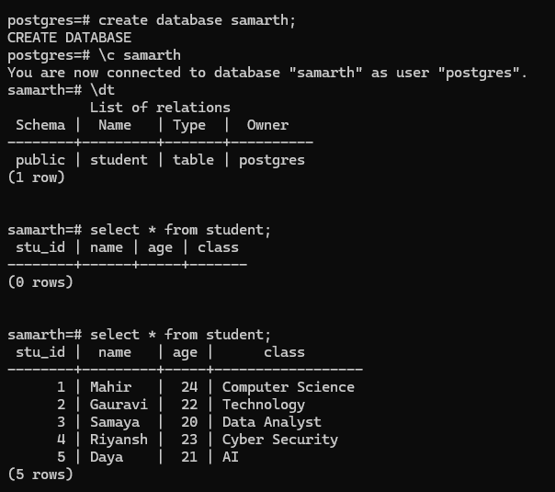

Q4. Create a Flask application connected with PostgreSQL. Create a Patient table and Search a patient using Patient ID and display the details.
Ans:
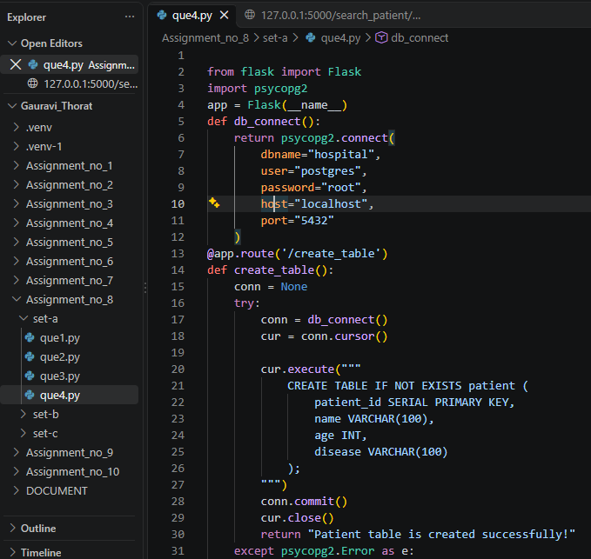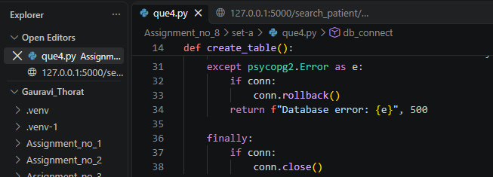

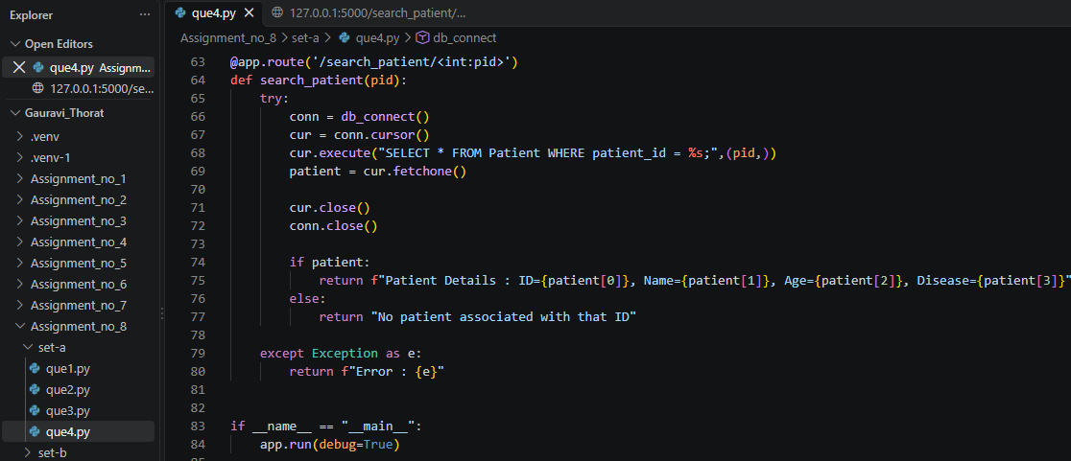
Output:
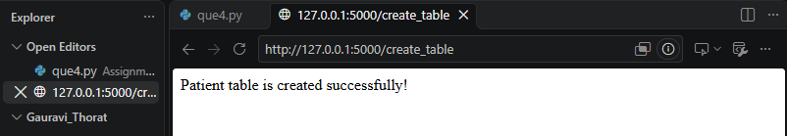
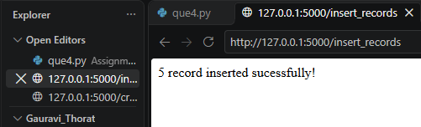
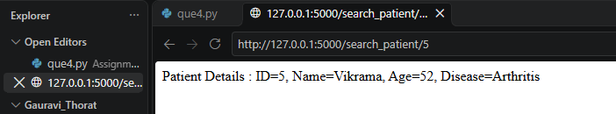
SET B :
Q1. Create a Flask application connected with PostgreSQL. Create a employee table and Search an employee using Employee ID and display Name, Department and Salary.
Ans:
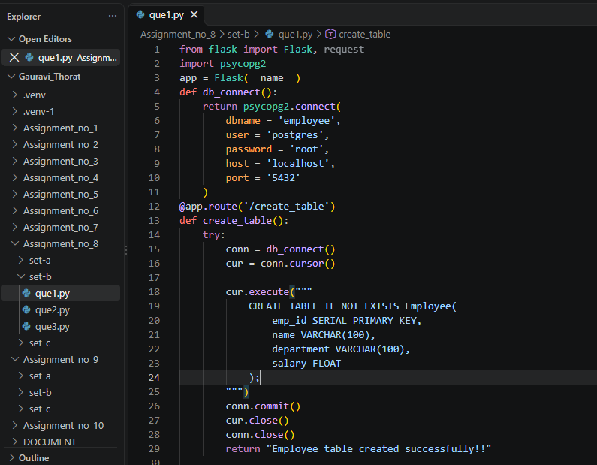
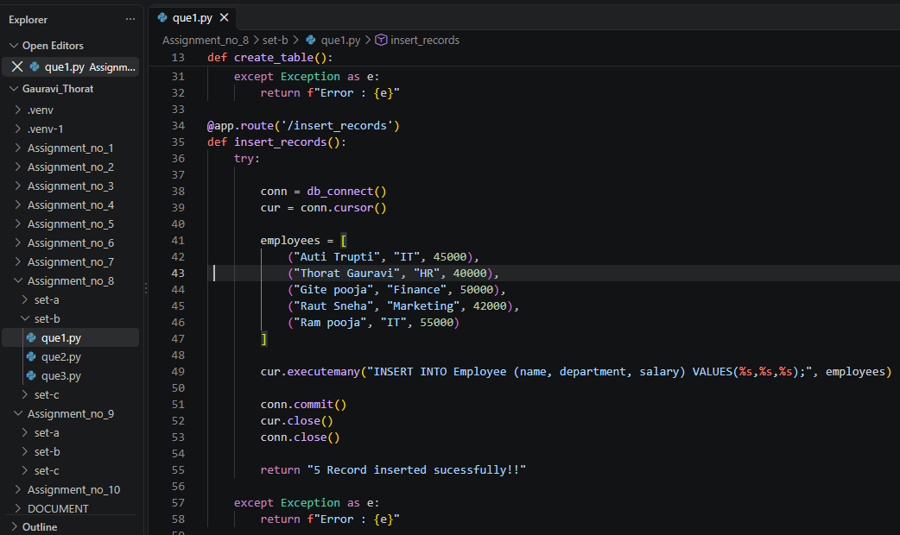
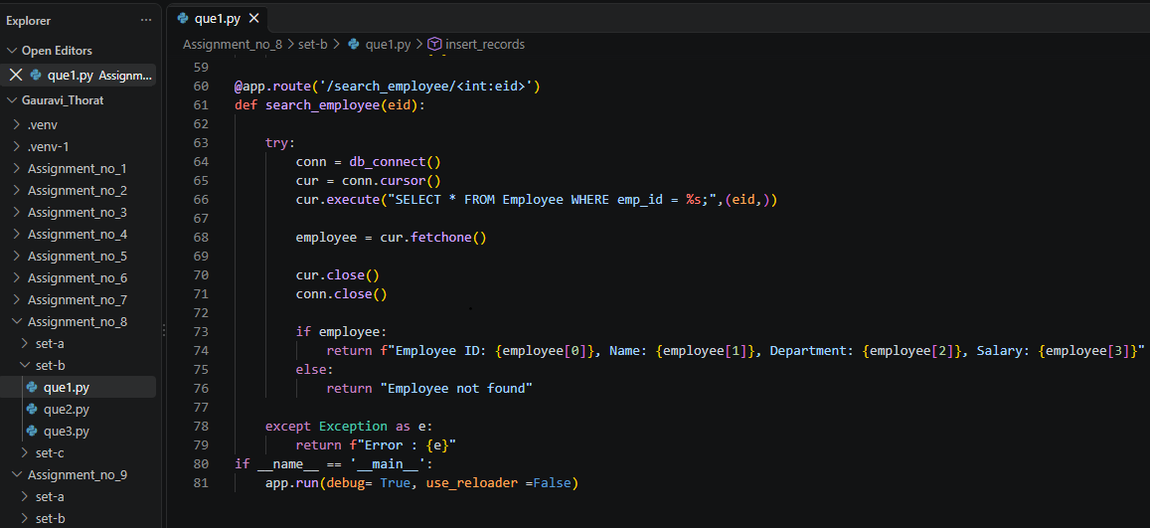
Output:
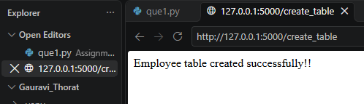
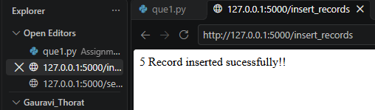
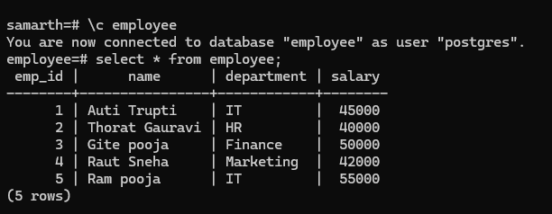
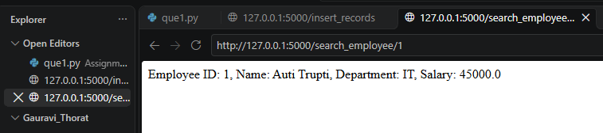
Q2. Create a Flask application connected with PostgreSQL. Create a Books table and Retrieve and display all books with their Author and Price.
Ans:
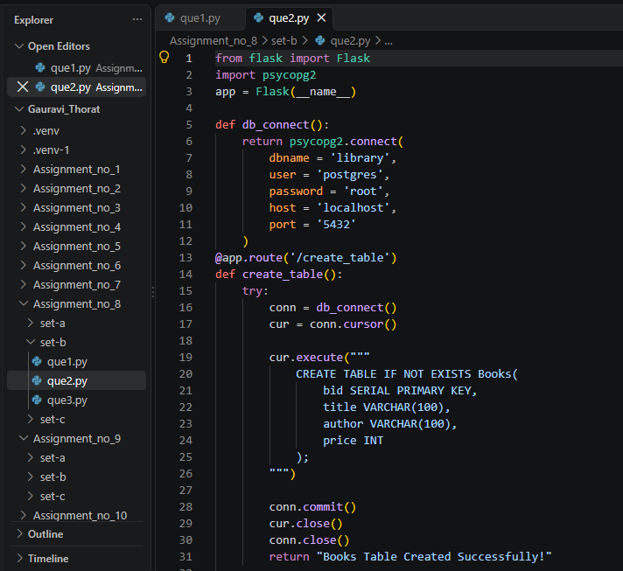
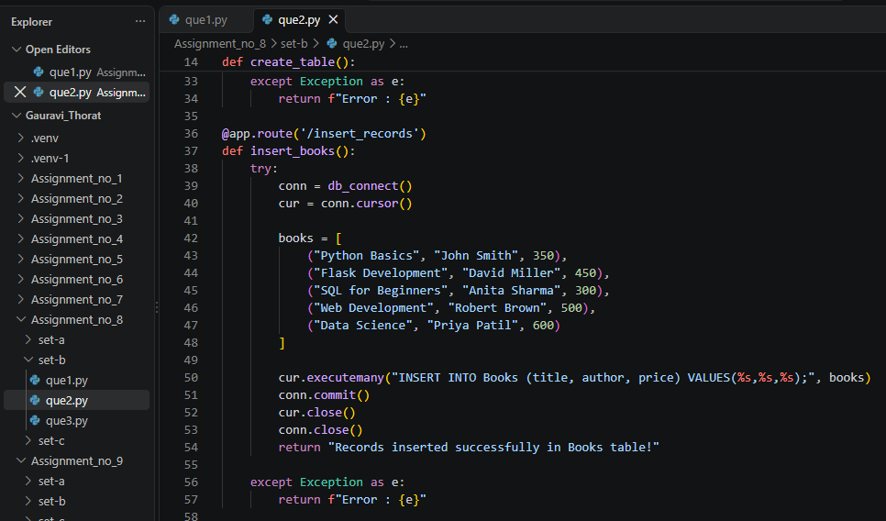
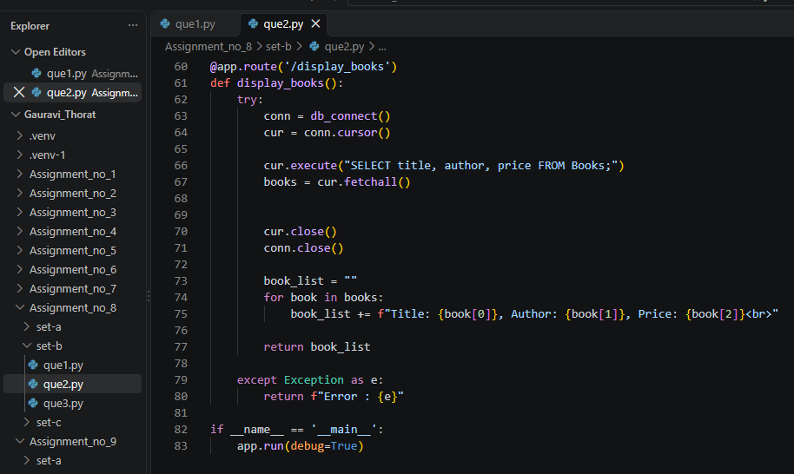
Output:
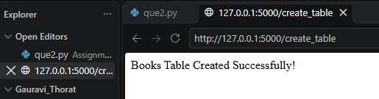
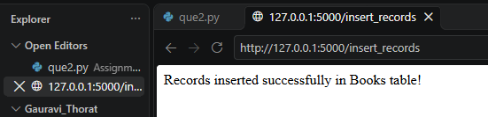
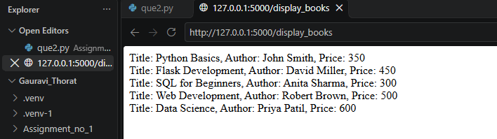
SET C :
Q1. Create a Flask application connected with PostgreSQL. Insert 5 employee records. Update an employee's salary and delete an employee using Employee ID. Display the final employee records.
Ans:
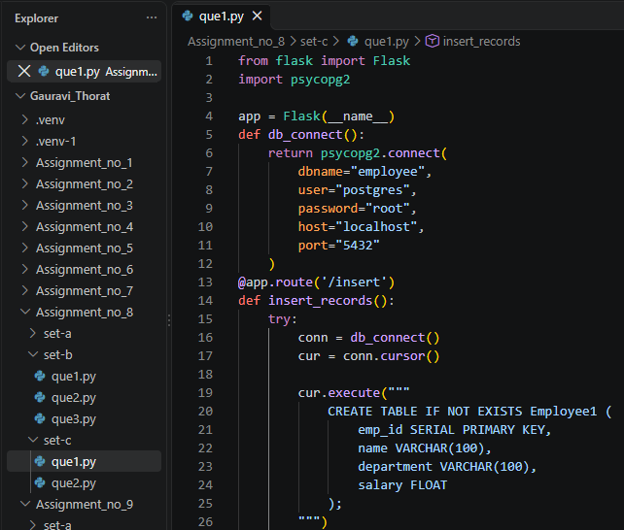
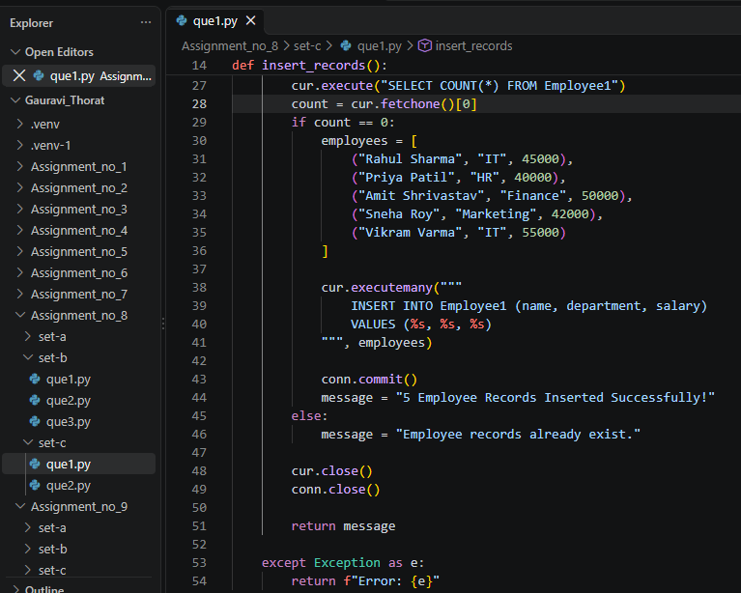
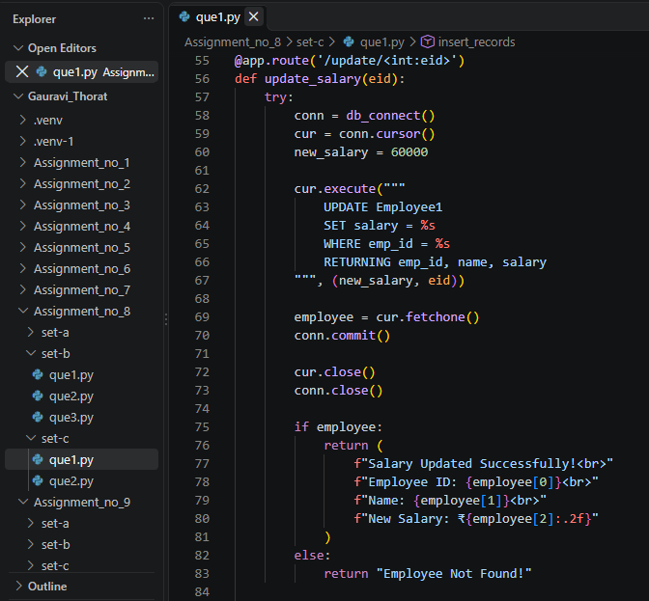
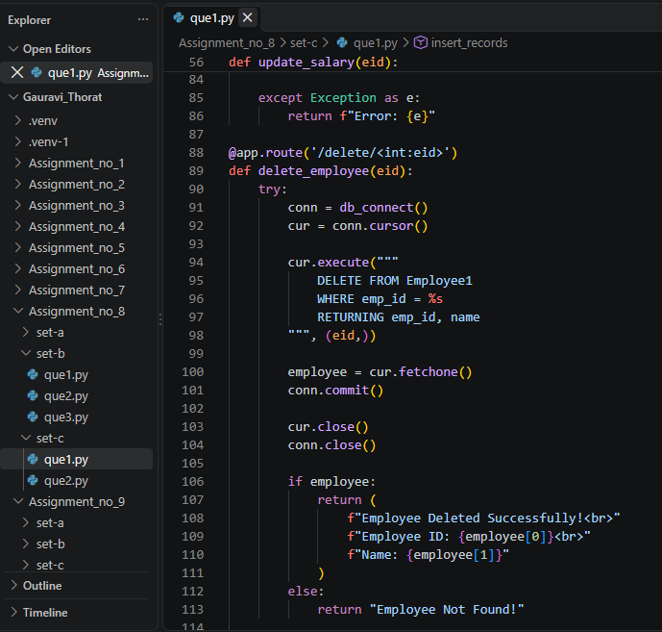
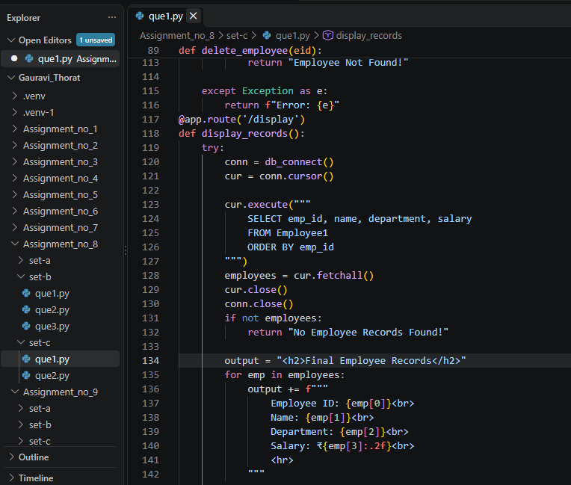
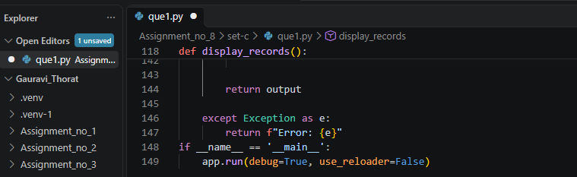
Output:
